Laboratoriya ishi-30
Mavzu: Loyihani yakunlash va taqdim qilish

Ishning maqsadi
- Web-ilovada foydalanuvchi xavfsizligini oshirish
- Botlardan himoyalanish uchun CAPTCHA yaratish
- PHP yordamida forma bilan integratsiya qilish
- Loyihani yakuniy holatga keltirish va ishlashini ta’minlash

Nazariy qism

CAPTCHA nima?
CAPTCHA (Completely Automated Public Turing test to tell Computers and Humans Apart) — bu foydalanuvchini robot emasligini aniqlash uchun ishlatiladigan test . CAPTCHA turlari:
- Matnli CAPTCHA (harflar va raqamlar)
- Rasmli CAPTCHA
- “I am not a robot” (reCAPTCHA)

PHP da CAPTCHA ishlash prinsipi:
- Tasodifiy kod generatsiya qilinadi
- Bu kod sessiyada ($_SESSION) saqlanadi
- Rasm sifatida chiqariladi
- Foydalanuvchi kiritgan qiymat bilan solishtiriladi

Amaliy qism (PHP loyiha)

Papka tuzilishi:

captcha_project/
│
├── index.php
├── captcha.php
├── check.php

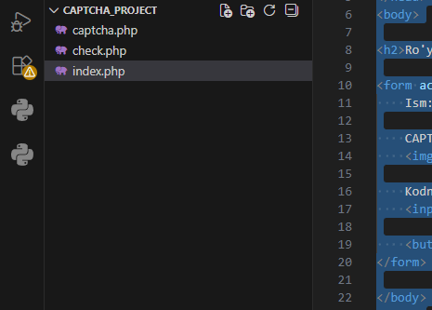

captcha.php (CAPTCHA rasm yaratish)

<?php
session_start();
$code = rand(1000, 9999);
$_SESSION['captcha'] = $code;
header("Content-type: image/png");
$image = imagecreate(100, 40);
$bg = imagecolorallocate($image, 255, 255, 255);
$textcolor = imagecolorallocate($image, 0, 0, 0);
imagestring($image, 5, 30, 10, $code, $textcolor);
imagepng($image);
imagedestroy($image);
?>

index.php (forma sahifasi)

<!DOCTYPE html>
<html>
<head>
<title>CAPTCHA Form</title>
</head>
<body>
<h2>Ro'yxatdan o'tish</h2>
<form action="check.php" method="post">
Ism: <input type="text" name="name"><br><br>
CAPTCHA: <br>
<img src="captcha.php"><br><br>
Kodni kiriting:
<input type="text" name="captcha"><br><br>
<button type="submit">Yuborish</button>
</form>
</body>
</html>

check.php (tekshirish qismi)

<?php
session_start();
$user_captcha = $_POST['captcha'];
if ($user_captcha == $_SESSION['captcha']) {
echo "✅ To'g'ri! Siz robot emassiz.";
} else {
echo "❌ Noto'g'ri CAPTCHA!";
}
?>
Natija
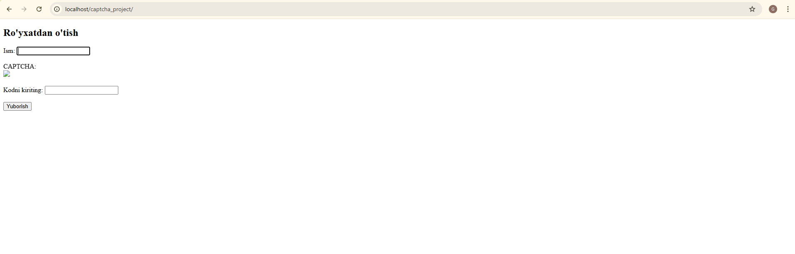
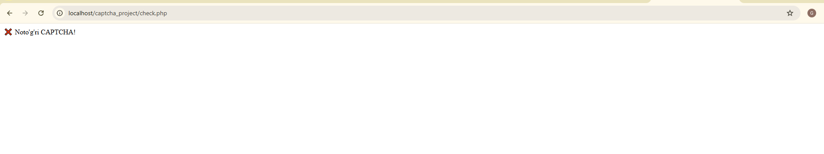
Xulosa
Ushbu laboratoriya ishida:
- CAPTCHA texnologiyasi o‘rganildi
- PHP yordamida rasmli CAPTCHA yaratildi
- Forma bilan integratsiya qilindi
- Loyihani yakunlash va test qilish amalga oshirildi
Natijada, web-ilovani botlardan himoya qilishning sodda, lekin samarali usuli ishlab chiqildi.

